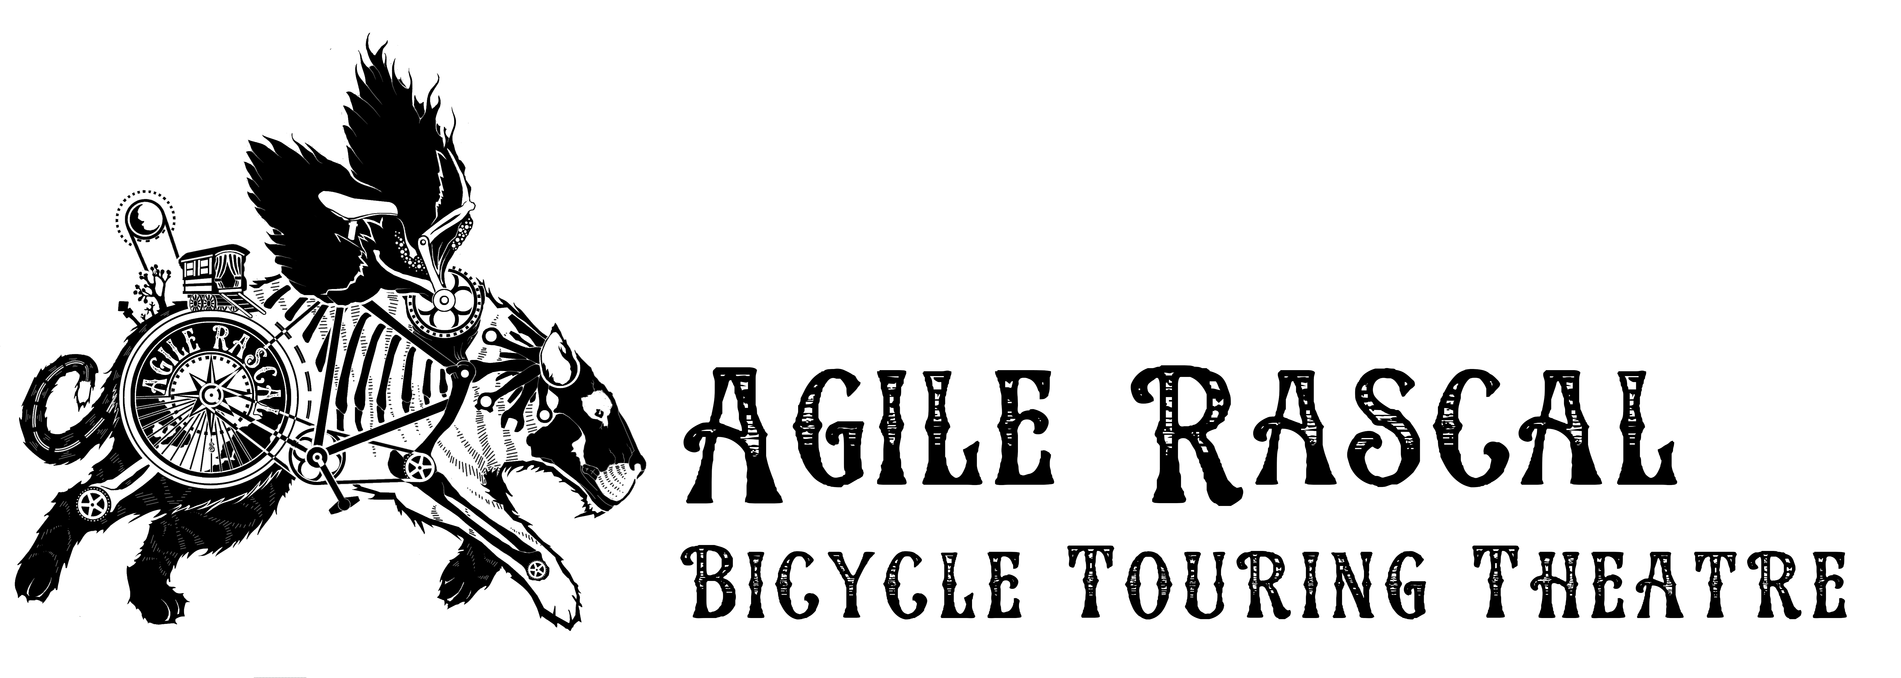

Florida 2019 Application

Name: Age:

Preferred Pronoun: Phone Number:
(Optional) Any Significant Identifiers (Ex: Race, Sexuality, disability or anything else about how you identify that you feel is important for us to know)

Email Address: Current Location:
Artistic Medium(s):
In a few sentences, please explain why you’d like to join Agile Rascal.

What questions are you currently asking in your creative life?

List your previous bicycling experience (No touring experience is by no means a deal breaker, we’re just trying to get a sense of skill level.)

List any other skills or experiences that you think might be useful (Yoga, Massage, crafting, Sewing, Bike maintenance, Cooking, First Aid, Mediation, Cooperative Living/Working, Fluency in other languages etc.)

Please attach a resume that includes training, previous artistic projects and any other relevant experiences.

Please include a link or two to work samples that highlight your best work.

